eof – energy optimizing furnace

EQUIPMENT PROFILE

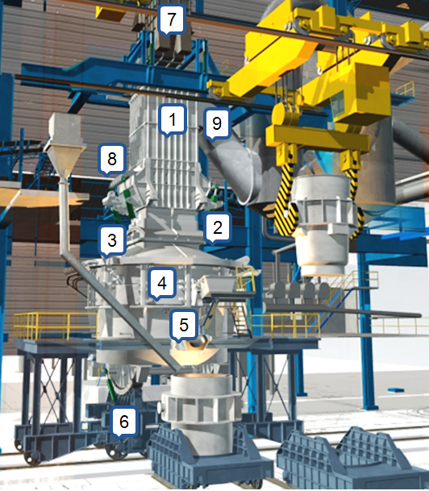

1 | SCRAP PRE-HEATER | 2 | SEALING SYSTEM | 3 | FURNACE ROOF
4 | FURNACE SHELL | 5 | FURNACE BOTTOM | 6 | BOTTOM CAR
7 | SCRAP BUCKET | 8 | FINGERS | 9 | FUMES DOWNCOMER

TECHNOLOGY  MINITEC Minitecnologias Ltda.  Rua Bananal, 405 - 5º andar - Bairro S. Antônio  CEP: 35500-036 – Divinópolis/MG. | TECHNICAL REPRESENTATION IN INDIA  YOJANA Engineering Solutions,  V-104, Siddarth Enclave,  Hospet, India, 583201.
Phone: (37) 3085-7113 - Fax: (37) 3085-7115  Email: minitec@minitec.eng.br  Website: www.minitec.eng.br | ASSISTANCE IN CONCEPTUAL ENGINEERING  DETAIL ENGINEERING  ASSOCIATED TECHINCAL SERVICES

- EOF - ENERGY OPTIMIZING FURNACE – EQUIPMENT PROFILE

  - Introduction
The EOF - “Energy Optimizing Furnace” - is a melting/refining oxygen based process for the production of liquid steel, starting from hot metal, with the addiction of of up to 40% scrap, preheated in the process. The unique proprietary scrap preheating process has a 25 year history of success. The EOF works with combined oxygen blow, (submerged and atmosphere oxygen), in an initial charge containing hot metal, preheated scrap and fluxes for slag formation.
Submerged oxygen reacts with the carbon from hot metal, generating CO bubbles. These bubbles travel through the liquid bath to the furnace atmosphere, where CO is burnt to CO₂ by the oxygen blown through atmospheric injectors and supersonic lances. Such CO bubbling generates an intense stirring and splashing that strongly increases the bath surface exposed to oxygen, allowing the transfer of an appreciable amount of heat to the bath and accelerating carbon oxidation. Sensible heat in the off-gas is used for preheating scrap, located above the furnace roof.
The following are some important features of the EOF:
- Combined oxygen blowing (submerged and atmospheric);
- Maximum utilization of the sensible heat from all reactions;
- Scrap preheating, using the sensible heat from the waste gases;
- Production of liquid steel combining hot metal and scrap in charge;
- Possibility of using high percentage of solid charge (up to 40 %);
- Special submerged tuyeres for submerged oxygen blowing, with long life;
- Efficient wet dedusting system;
- Deslagging and formation of second slag during blow;
- Liquid steel of highest purity, with very low level of phosphorous and sulfur;
- Low noise level;
- Highest productivity - up to an average of 45 heats per day.
Combining the above features, the EOF presents a lower cost production than any other route, combined with great flexibility with regard to the metallic charge mix.

  - Description of main equipment
The EOF proper is a melter based on oxygen blowing - submerged and into the furnace atmosphere - in order to achieve the melting, decarburizing, dephosphorizing and desulphurizing of the charge. The following components make part of the EOF:

    - Bottom car
Comprehends 2 units of shuttle type in order to allow quick bottom exchange for a new campaign. One bottom car supports the EOF furnace in operation and the other one supports a second bottom for relining and the shell. Both cars are equipped with roll collar tracks to tilt the furnace for tapping or deslagging. Tilting is performed by high speed hydraulic cylinders, allowing slag-free tapping.
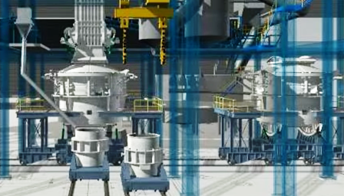 | 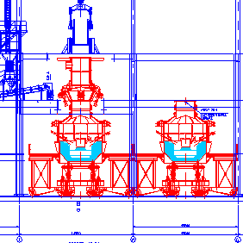

    - EOF proper
The bottom is lined by refractory bricks. The shell, the roof and the sealing system are made with cooled water panels. The sealing system allows tilting of the EOF any time. Each EOF unit comprises:
- Hot metal launder;
- Steel tapping launder;
- Submerged tuyeres;
- Atmosphere injectors and supersonic lances for oxygen blowing;
- Oxy-fuel burners for heating-up new bottom.

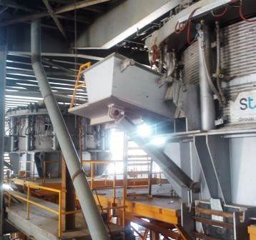 | 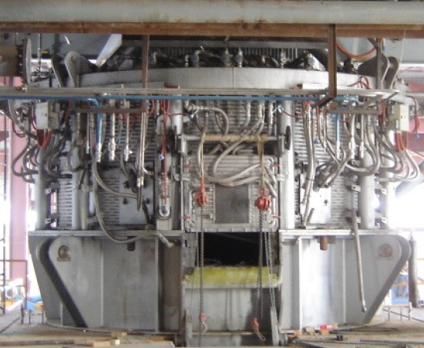

    - Scrap Preheater
The scrap preheater, an essential part of the EOF and a design with 25 years of success, features one layer of water cooled fingers on which cold scrap is deposited. Hot off-gas evolved from the EOF flows through the scrap, heating it up to 850 ºC. The fingers are tilted in order to drop the scrap into the furnace, returning to their original position for a new charge.
The Scrap Preheater is placed immediately above the furnace, provided with water-cooled panels and tilting fingers. A water-cooled pipe placed below the fingers allows the addiction of fluxes, alloys or DRI into the furnace. Further items are: off-gas uptake and scrap charging system, both placed at the Scrap Preheater top.
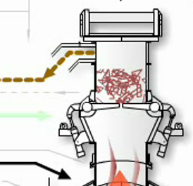 | 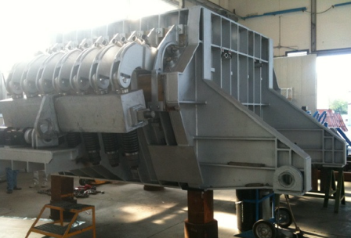

    - Gas Cleaning Plant (GCP)
The GCP is wet system type, with lined downcomer duct provided with water sprays, vertical quenching chamber with water sprays, emergency stack for off-gas exhaust in case of power failure, venturi type scrubber, mist collector, ID fans with control dampers and stack, placed outside the building. Optionally dry GCP may be installed.
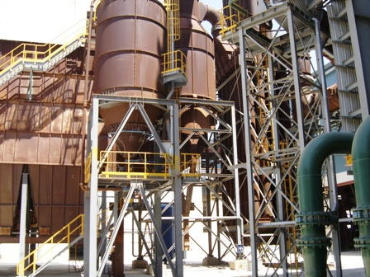 | 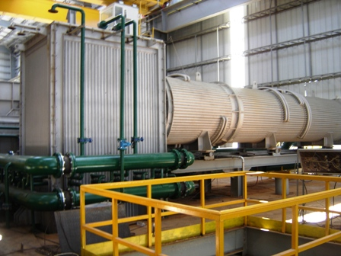

    - Alloys and fluxes system
Alloys & fluxes system comprises weighing and feeding units for furnace additions during melting and ladle addition during tapping.
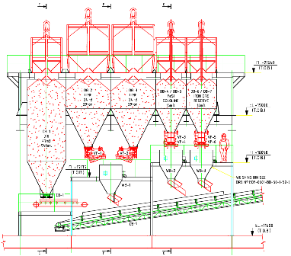 | 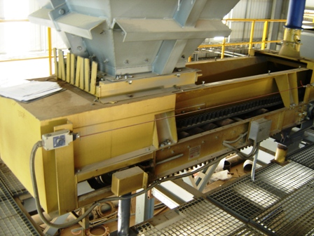
    - Valve Stand
The Valve stand promotes the flow commands of the submerged tuyeres, atmosphere injectors, oxy-fuel burners and supersonic lances.
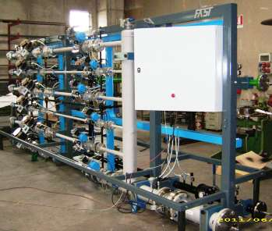 | 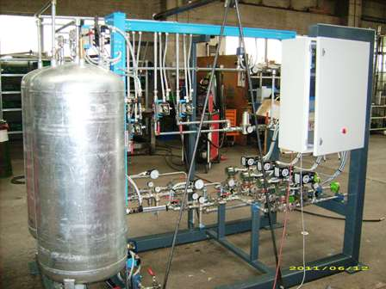

    - Hydraulic power pack
Hydraulic power pack for:
- Furnace tilting and
- All hydraulic components of the Scrap Preheater and local hydraulic pulpits/panels for maintenance.
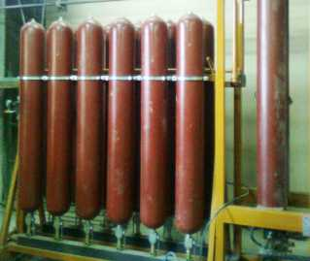 | 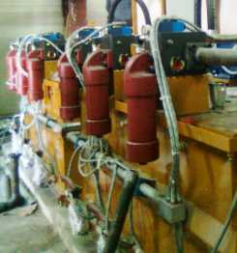

    - Control room
The control room is placed at working platform level, for the control of all operations of the furnace and Scrap Preheater.
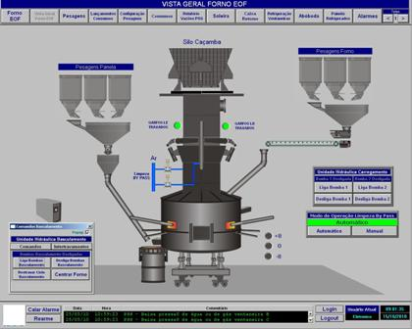 | 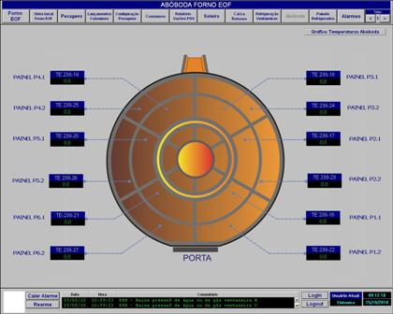

    - Slag Pit
The slag pit is placed in front of the furnace working door and below the working platform.
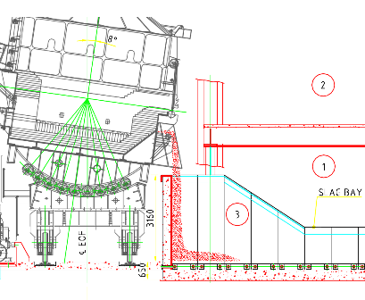 | 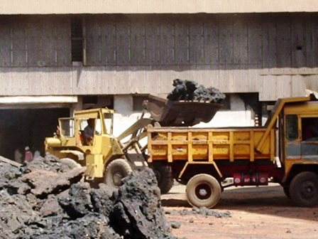

    - Over Head Cranes
- OH crane for handling of scrap buckets, alloys & fluxes bags/containers and maintenance services.
- OH crane for hot metal pouring into the furnace and maintenance services in the pouring/tapping area.
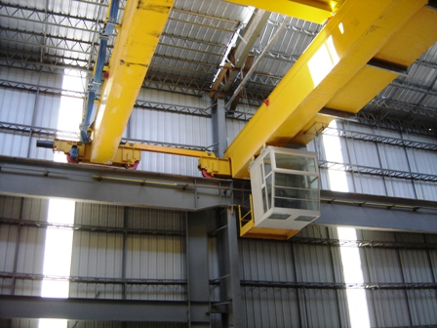 | 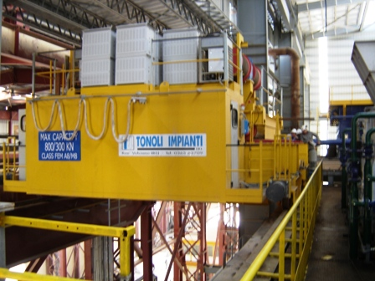

    - Scrap buckets
Scrap buckets for handling and releasing the cold charge into Scrap Preheater.
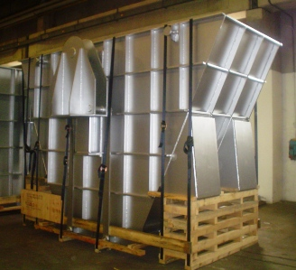 | 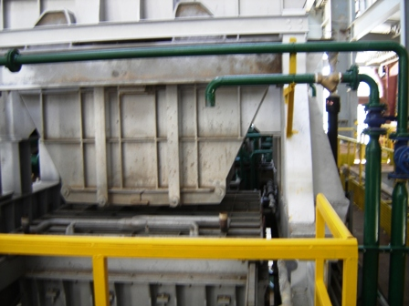

    - Measurement and control instruments
- Sampling equipment for steel and slag analysis.
- Liquid steel temperature measurement equipment.
- Liquid steel carbon measuring equipment.

  - EOF advantages
The EOF presents some outstanding advantages:
- Extreme flexibility with regard to the metallic charge mix;
- No use of electrical energy for melting;
- High plant productivity and availability, industrially proven;
- Excellent metallurgical properties, specially with regard to dephosphorisation and desulfurization;
- Low content of tramp elements in steel;
- Continuous flushing of slag during the blow, slag free tapping;
- The steel tapped may be directly transferred to the secondary metallurgy in ladle furnace and vacuum treatment unit in case of special steels production;
- Easy process control, fully automated;
- Energy savings, due to:
- High post combustion rate (95 %);
- Good transfer rate of post combustion heat to the bath (30 %);
- Scrap preheating up to 850 ºC;
- High operational efficiency;
- Constructive features which are industrially proven for more than 20 years:
- Horizontal submerged tuyeres for oxygen injection;
- Utilization of water cooled panels for shell walls and roof;
- Oxygen injectors and oxyfuel burners;
- Supersonic lances for oxygen injection;
- High efficiency Scrap Preheater, also lined with water cooled elements;
- Exchangeable bottom, in shuttle arrangement, which may be replaced up to 6 hours.
- Operation under slightly negative pressure
- No secondary dust emissions.
- Compliance with environmental regulations, with wet or dry gas cleaning system.
- Low noise levels and dust emission.

  - Steel quality aspects
The EOF is suitable to produce all steel qualities; tapped steel presents chemistry typical for steel obtained from combined blowing process. Due to the continuous slag flushing practice an excellent dephosphorisation (up to 0,008 %) and desulphurisation (up to 0,025 %) are attained.
Working with high percentage (>60 %) of hot metal in the charge, the EOF has as final product a steel with very low content of tramp elements, which means a great advantage when producing special steel grades such as die forging steels, specially clean steels, steels for seamless pipes etc.
The high CO partial pressure during the whole blowing period leads to very low nitrogen and hydrogen content in the steel as tapped.
Same as for all steel making routes in case of high quality and special steels, a secondary metallurgy is required, e.g. ladle refining, vacuum degassing etc.

  - Application
The EOF is an economical process for all steel production routes. The advantages are greatest, however, when at least 60% hot metal are available - either from blast furnace, cupola or from smelting-reduction processes like Corex, HiSmelt, Tecnored etc.
Furthermore, in case of low availability of electrical energy the EOF becomes the solution. The flexibility regarding solid charge materials (scrap, pig iron, DRI, HBI) is a further attraction.
The ideal EOF application lies in areas with electrical energy deficit and scrap shortage. Upon availability of Hot Metal, a certain annual volume of pig iron will be produced, which, with the addition of other metallic will allow a steel production almost double that of hot metal availability.

A MINI STEEL PLANT of such a concept, duly equipped with a ladle furnace and CC Machine, presents the following advantages:
- It will not depend on substantial availability of electric energy
- It does not require availability of much scrap; if readily available, however, scrap may be utilized to almost 40 % of the charge
- It yields highest productivity
- It presents reduced production costs - lower than any other route
- It features improved environmental compliance - by lowering noise levels, reducing primary and secondary dust emissions
- It requires lowest capital cost
- It warrants highest cleanliness in steel

  - Basic characteristics
The EOF furnaces are designed for 30/40 t, 60/80 t and 100/120 t capacity and have the following basic characteristics and dimensions (may be changed without notice):
Hearth surface: 6,6 to 22,0 m²
- Shell diameter: approx. 5,3 to 7,5 m
- Total height from working platform to top level: approx. 17 to 25 m.
- Number of scrap preheater stages: 1 or 2 stages.
- Tilting angle for tapping: up to 8°.
- Tilting angle for deslagging: up to 8°.

EOF building structure:
- Width : 16 to 20 m
- Length : 64 to 70 m
- Height : 25 to 30 m from floor level to OH crane rail top.

  - Performance
The following data are characteristic for the performance of a conventional EOF:
Furnace availability: - 340 days per year
Charge composition: hot metal - 60 % to 100 %
solid charge - 40 % to 0 %
Tap to tap time: - 30 to 50 minutes
Oxygen consumption: - 50 to 70 Nm³/t
Oil consumption (heating of new bottom): - 0,5 to 1,0 kg/t
Refractory consumption: Relining - 1 to 2 kg/t
Gunniting - 3 to 6 kg/t
Heats per campaign: - 800 to 1.500
Bottom exchange (between campaigns): - 2 to 12 hours

  - Specific consumption figures for conventional production
(t/t of liquid steel)

Hot Metal (example) - 778 kg/t (70 %)
Pig iron and Steel Scrap (example) - 333 kg/t (30 %)
Metallic yield - 87 to 89 %
Lime - 45 kg/t (depending on P in hot metal)
O₂ - 50 to 70 Nm³/t
N₂/CO₂ - 3 to 5 Nm³/t
Fuel - 5 to 10 Mcal/t
Tapping temperature - 1650 ºC (aprox.)

  - Main items comprised in the EOF
- EOF building with OH crane, furnace proper and scrap preheater, gas cleaning plant, water systems for gas cleaning plant and for water cooled elements, electrical, control and instrumentation, thickener.
- Furnace Proper
Bottom, shell and roof water-cooled elements, burners, injectors, tapping system, instrumentation and control.
- Scrap Preheater
Shell, fingers, water-cooled panels, movable roof, scrap bucket opening system.
- Gas Cleaning System
Ducting, expansion chamber, venturi scrubber, cyclone, control valves, ID fans with control dampers, flow measurement system, stack, water circuit for cleaning including pumps, thickener, etc.
- Scrap charging equipment
Scrap bucket, transfer car, OH cranes, scrap bay etc.
- Scrap bay, crane with electromagnet, weighing system, car for scrap bucket, scrap bucket etc.
- Refractories
Bottom, scrap preheater, hot metal launder and tapping launder, ladles, ducts etc.
- Additive and alloy system (at EOF building)
Bins, weighing and discharging system charging are ducting into the furnace and steel ladle.
- Hydraulic System
Furnace tilting device, scrap bucket opening, fingers and movable roof movement etc.
- Cooling water system
Cooling tower, pipes, fittings, pumps, chemical treatment etc.

- Slag, hot metal and liquid steel handling system, steel and hot metal ladle, slag pots, optional vehicle for hot metal transportation, equipment to remove slag, slag and steel ladle car etc.
- Gases and fluids system
O_{2,} CO₂/N₂, air, fuel, piping, control panels etc.
- Electrical, Control and Instrumentation.
Main sub station, transformers, switchgear, MCCs, motors, cables, PLC,
software, sub station and illumination.

  - Scope of services
The scope of services offered by MINITEC is as follows:
- Conceptual Studies for EOF-based Mini Steel plants;
- Feasibility Studies for EOF-based steel melt shop implementation;
- Complete basic and detail engineering for EOF melt shop and EOF proper;
- Technical assistance for Procurement, Manufacture and Erection;
- Assistance for Commissioning and Start-up;
- Training and Operational Assistance.

EOF – is the most flexible and efficient solution for steel production. 